**Abstract Template for The 16th CSE Summer School  
 and The 13th ALP International Symposium**

**Presenting Author,1 Second Author,2 Author Pendragon1,2**

1Department/Institute/Center, Hokkaido University, Sapporo, Japan

2Department/Institute/Center, Hokkaido University, Sapporo, Japan

*E-mail*: presenting_author@email.jp

***Keywords***: Science, Chemistry, Chemical Engineering

**[Introduction]**

The 16th CSE Summer School & The 13th ALP International Symposium will be held on November 8-9 at Sapporo Ainu Culture Promotion Center “Sapporo Pirika Kotan” [1] (**Figure 1**), and Koganeyu Onsen Matsu no Yu [2], Sapporo. The place is famous for *onsen* (hot springs), which are especially good in the winter. Other topics of this venue throughout the four seasons are shown in Table 1. It takes about one hour from Hokkaido University by bus.

**[Preparation and submission of the Abstract]**

The abstract should be no more than one page in A4 size [4]. We strongly recommend using this template to prepare your abstract. The title, authors, and affiliations should be centered. Presenter should be underlined. Times New Roman font is recommended. You can include figures (Fig. 1) or tables (**Table 1**). To facilitate communication, please provide a brief profile of the presenter with a photo (color acceptable) below. The content, style, and size of the profile part is open to change.

The abstract should be submitted via Google form [5]. Only the document of the pdf format will be accepted. The file name should be “Abstract_YOURFAMILYNAME.pdf”. File size must be less than 100 MB.The deadline for abstract submission is **October 27 (Mon.)**.

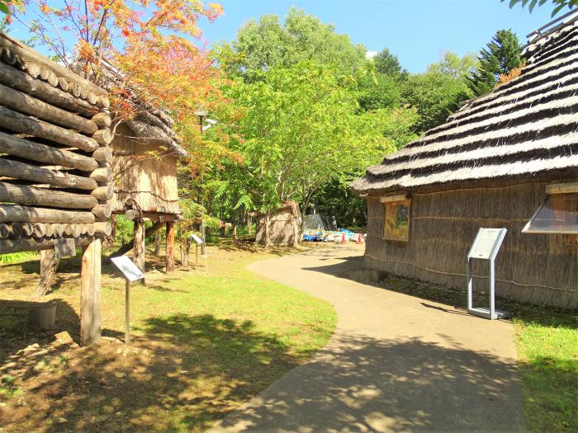

**Figure 1.** Image of the Pirika Kotan,taken from the official website of the City of Sapporo [1].

**Table 1.** Four seasons of Koganeyu [3].

|  |  |
| --- | --- |
|  | Activities |
| Spring | *Hanami* picnic after melting of snow |
| Summer | Beautiful green of woods and fruits hunting |
| Autumn | Autumn leaves on *Hakkenzan* mountain |
| Winter | White of snow and comfortable *onsen*. |

[1] <https://www.city.sapporo.jp/shimin/pirka-kotan/shisetsu/index.html> (Accessed October 6, 2025).

[2] <http://www.matsunoyu.co.jp/index.html> (Accessef October 6, 2025)

[3] <https://koganeyu.jimdofree.com/> (Accessed October 6, 2025).

[4] A4: 210 mm × 297 mm

[5] Abstract submission: <https://forms.gle/BDkWt319kPSHrrsp9>

*Short profile*

Presenter’s

Photo in color

any size and kind

is acceptable

**Education:**

BSc., Hokkaido University, Japan; MSc. Cambridge University, UK; PhD, University of Harvard, USA

**Honors and Awards**

President Awards 2018, Hokkaido University, MEXT Scholarship 2017, etc.

**Interests and hobbies (scientific and/or personal)**

Catalysis, Driving, Clubbing, etc.