Abstract title (Title in Times New Roman, 13 pt bold, centered)
Presenting Author,¹ Second Author,² Third Author^{1,2}
(Authors’ Names in Times New Roman, 11 pt bold, centered)
¹Department/Institute/Center, Hokkaido University, Sapporo, Japan
²Department/Institute/Center, Hokkaido University, Sapporo, Japan
E-mail: presenting_author@email.jp
Keywords: Science, Chemistry, Chemical Engineering, Heterogenous Catalysis [maximum 5 words; 11 pt]
[Times New Roman, 11 pt, justified] A short abstract indicating the main findings of the work within a one A4 size page.^{1,2} Abstract should be submitted online by email in MS Word and PDF formats; the email subject is written as “Author name - Abstract for CSE-ALP International symposium”. The file should be named as “Last name_Abstract”, corresponding to the Presenting Author (e.g., Asakura_Abstract.pdf).
We strongly recommend following the format of this document and type the abstract over this template, so that all abstract contributions have the same style in the final publication, i.e., text written in Times New Roman 11 pt. (justified).
Please insert the Figures (color/black & white) and Tables named as “Fig. No.” and “Tab. No.” (e.g., Fig. 1, Tab. 1). The corresponding captions (Times New Roman 9 pt) should follow immediately after the Figures and before the Tables, without any line between the Figure/Table and its caption.
The sections for acknowledgements and references can appear (if required) at the end of the abstract (Times New Roman 9 pt). References should be sequentially numbered in the text and indicated (as superscript) after the punctuation signs (e.g., “…catalysis.^{1,2}”).

Please write a short profile of the presenting author below this textbox with his/her photo (possible in color). The author can freely modify the content, style and size of this part.

Reference:
1. A. Author, B. Author, C. Author, ACS Catal. 2019, 8, 1001−1010.
2. A. Author, B. Author, Chem. Sci. 2017, 8, 1001−1010.
(Short profile: Few words about yourself – please, modify this part as you like; an example is shown below)
Presenter’s
Photo in color

any size and kind
is acceptable
Education:
BSc., Hokkaido University, Japan; MSc. Cambridge University, UK; PhD, University of Harvard, USA
Honors and Awards
President Awards 2018, Hokkaido University; MEXT Scholarship 2017, etc.
Interests and hobbies (scientific and/or personal)
Catalysis, Driving, Clubbing, etc.
Graphical Abstract Format

Please prepare the graphical abstract within a 17 cm width × 3.6 cm height box.
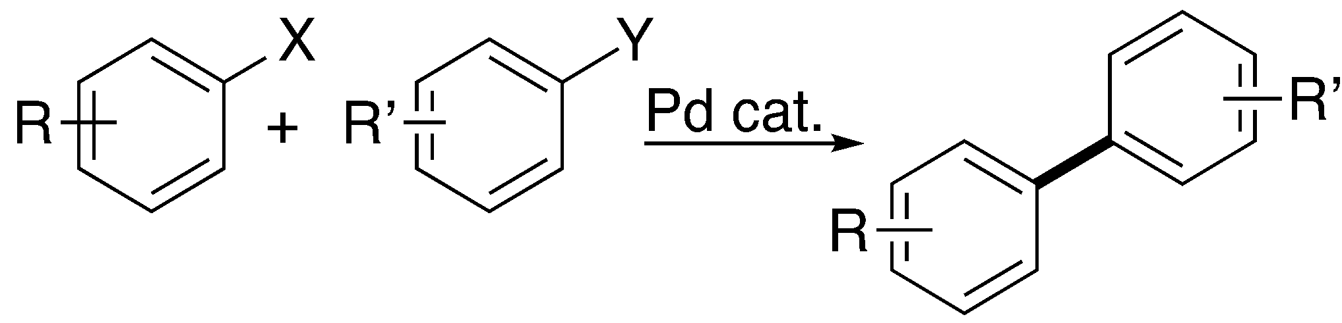
The example below can be used as a template.

Abstract title (Title in Times new Roman, 10 pt, bold)
Presenting author, second author, Third aurhor, ...
(Authors’ Names in Times New Roman, 9 pt)

Department/Institute/Center,

• Graphical Abstract should be submitted on-line by email as .png formats.
• The file should be named as “Last name_ GraphicalAbstract”.

